### Name: ____________________________________

| Exam 1 – Spring 2019 VERSION Dh by | |
| --- | --- |
| Course Information: Phys 2B | Instructor Name: John R. Walkup |

***d*** = ***v***o*t* + (1/2)***a****t*2 ***v*** = ***v***o + ***a****t*  ***F***net = *m****a*** ***F***g = *m***g** *V* = *kQ/r  V* = *Ed R = L/A*

*WC = –*PE *WNC =* E *Wnet =* 😐E *W* = *Fd*cos     😐  *mv*2 *F*Q = *kQ*1*Q*2*/r*2 PE = *kQ*1*Q*2*/r*

*V = IR k* = 9 X 109 in SI *C = Q/V e =* 1.6 X 10-19 *C* 1 mC = 10-6 1 nC = 10-9 C

*If none of the numerical responses matches your solution, choose the closet numerical value.*

#### Multiple-Choice Questions

1. 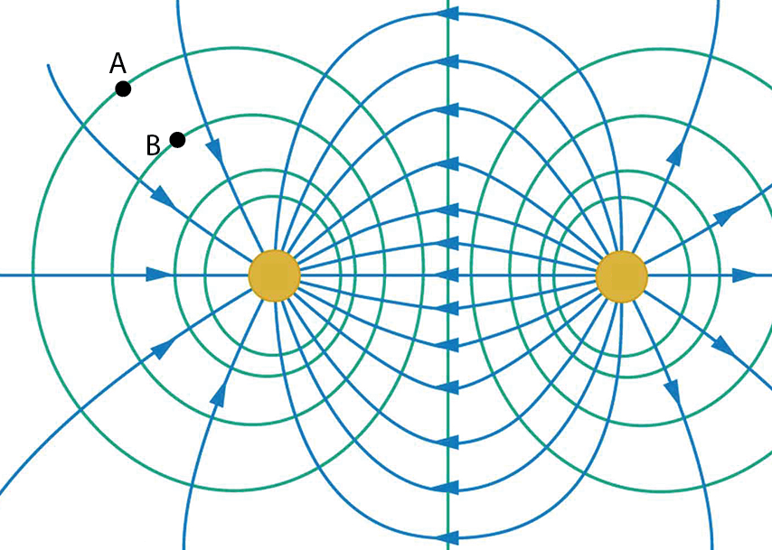An electric field (arrows) and corresponding equipotential lines are shown in the figure. A negative charge is traveling through the field with no other forces acting on it other than that produced by the electric field. As it moves from Point A to Point B…
2. Its potential energy decreases, its kinetic energy increases, its total energy stays the same.
3. Its potential energy, kinetic energy and total energy all increase.
4. Its potential energy increases, its kinetic energy decreases, its total energy stays the same.
5. Its potential energy, kinetic energy and total energy all decrease.
6. I grab the electrode of an electroscope (therefore grounding it). I then place a positively charged rod near the electrode but not close enough to touch it. I let go of the electrode and then pull the rod away from the electrode. What happens?
7. The leaves will be spread apart because they are both positively charged.
8. The leaves will be spread apart because they are both negatively charged.
9. The leaves will not spread apart because they are not charged once the rod is pulled away from the electrode.
10. Neither will happen because you pulled the rod away from the electrode after you let go of it.
11. The leaves will not spread apart because one will be charged positively while the other charged negatively.
12. 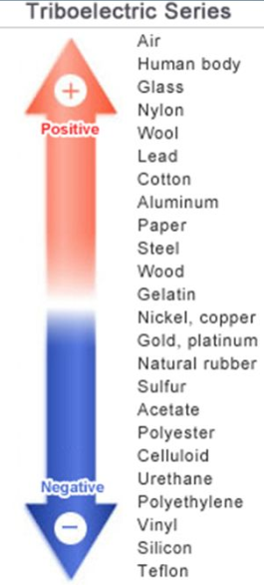I rub wool against glass. What happens?
13. Nothing, as neither of these items are insulators
14. Nothing, as one material is a conductor and the other is an insulator.
15. Electrons are transferred from the wool onto the glass.
16. Electrons are transferred from the glass onto the wool.
17. Protons are transferred from the wool onto the glass.
18. A conductor is placed inside a non-constant electric field.
19. The presence of the conductor zeroes out the electric field both inside and outside the conductor.
20. The electric field outside the conductor is unaffected, but vanishes inside the conductor.
21. The electric field inside the conductor will eventually become constant throughout the conductor but not necessarily 0, depending on how much charge is on the conductor surface.
22. The electric field is 0 everywhere inside the conductor. Outside the conductor the electric field is distorted by the conductor.
23. The conductor has no effect at all because it is not an insulator.
24. 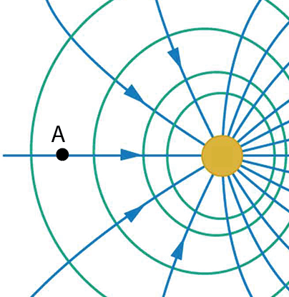An electric field (arrows) and corresponding equipotential lines are shown in the figure. At point A…
25. A negative charge placed at Point A would have a force exerted on it roughly upwards.
26. A negative charge placed at Point A would have a force exerted on it toward the left.
27. A negative charge placed at Point A would have no force exerted on it.
28. A negative charge placed at Point A would have a force exerted on it toward the right.
29. There is no way to answer this question.
30. 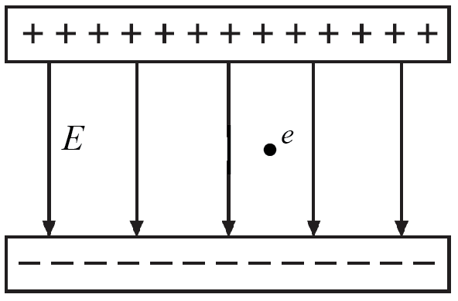An positively-charged proton is placed between the two charged plates shown in the figure. Once released, it will move towards the negative plate. In so doing, it will
31. Increase its potential energy, kinetic energy, and total energy.
32. Lower its potential energy, kinetic energy, and total energy.
33. Lower its potential energy and raise both its kinetic energy and total energy.
34. Raise its potential energy and lower both its kinetic energy and total energy.
35. Lower its potential energy, raise its kinetic energy, but not change its total energy.
36. There is an old saying that it is safer to stay inside your car during a lightning storm.
37. They are wrong. A car is possibly the most dangerous places to be in a lightning storm.
38. They’re right. Rubber tires make it nearly impossible for lightning to pass through the car into the ground.
39. They’re right because electrons in the metal shield the electric field from the passengers inside the car.
40. They are right because a car body is smooth with relatively few points to attract lightning.
41. 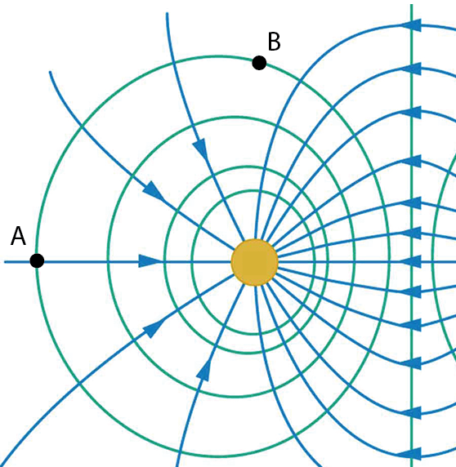They are right, but no one is sure why. Statistically, we just know that fewer people are hurt when inside a car than in other places.
42. The figure shows an electric field and corresponding equipotential lines. If a charge moves from Point A to Point B, what happens to its potential energy?
43. It rises if it is a negative charge, but lowers if it is a positive charge.
44. It lowers if it is a negative charge, but rises if it is a positive charge.
45. It rises regardless of whether it is a positive or negative charge.
46. It drops regardless of whether it is a positive or negative charge.
47. It stays the same.
48. Some of the charges on this exam are expressed coulombs, like 4 C or -8 C.
49. This is perfectly reasonable.
50. This is not preferred as the Coulomb is not the SI unit of charge.
51. This is unrealistic, as the coulomb is an incredibly tiny amount of charge.
52. This is unrealistic, as the coulomb is an enormous amount of charge.
53. In deep space, two spheres of negligible size are connected by a 200-meter nonconducting cord. If a uniformly distributed charge of 0.04 C resides on the surface of each sphere, calculate the tension in the cord.
54. 1,800 newtons
55. 9,600 newtons
56. 18,000 newtons
57. 4,500 newtons
58. 0 newtons
59. An electron is accelerated by a constant electric field of magnitude 410 N/C. Find the acceleration of the electron. The electron has a charge of *e* = 1.6 X 10-19 C. <https://brainly.com/question/14603606>

a = \dfrac{1.6\times 10^{-19}\times 410}{9.11\times 10^{-31}}

1. 1.82 X 108 m/s2
2. 6.56 X 1013 m/s2
3. 0
4. 2.56 X 1021 m/s2
5. 3.90 X 10-22 m/s2
6. A charge *q* = 4 C is accelerated by a constant electric field of magnitude 325 N/C in the opposite direction of the electric field. After it has traveled a distance 0.1 meters, what has happened to its kinetic energy?
7. Its kinetic energy increases by 130 joules
8. Its kinetic energy decreases by 130 joules
9. Its kinetic energy increases by 260 joules
10. Its kinetic energy decreases by 260 joules
11. Its kinetic energy does not change
12. 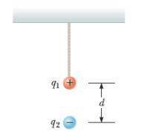A small sphere of mass *m* = 7.60 g and charge *q*1 = 30.6 nC is attached to the end of a string and hangs vertically as in the figure. A second charge of equal mass and charge *q*2 = −58.0 nC is located below the first charge a distance *d* = 2.00 cm below the first charge as in the figure. Find the tension in the string. (Use *g* = 9.8 m/s2 .)
13. 0.114 newtons
14. 0.262 newtons
15. 0.450 newtons
16. 0.646 newtons
17. 0.084 newtons

#### Free response

1. 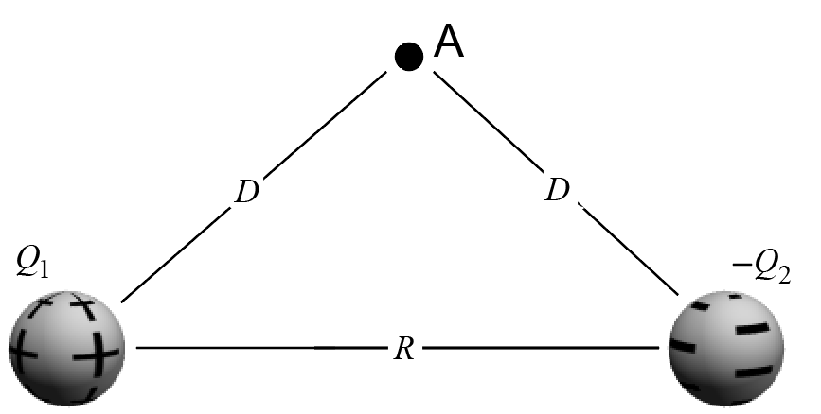Pictured are two point charges. Here, Q = 3 mC and Q2 = – 3 mC and *R* = 10 m and *D* = 8 m.   
   At Point A, find
2. The electric field strength and direction.
3. The potential.
4. The force on a charge of *q* = – 2 mC if placed at Point A including its direction.
5. The potential energy of this charge *q* if placed at Point A.
6. 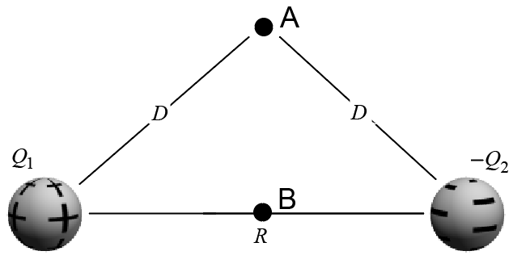Consider the same two point charges and same values as in the previous question.
7. Calculate the absolute value of the voltage difference between points A and B.
8. If a negative charge *q* = – 2 mC moves from Point A to Point B, what will be its change in potential energy?
9. Will the potential energy rise or drop as the charge moves from Point A to Point B? Explain.
10. A small plastic ball of mass *m* = 3.00 g is suspended by a string of length *L* = 21.0 cm in a uniform electric field, as shown in the figure below. If the ball is in equilibrium when the string makes a *θ* = 14.0° angle with the vertical as indicated, what is the net charge on the ball?

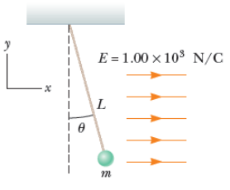

1. 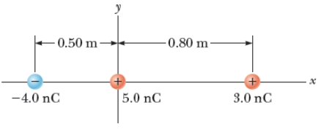Three point charges are aligned along the x-axis as shown in the figure below. Find the electric field at the position x = +4.2 m, y = 0.
2. State the purpose of the …
3. …electric field
4. … the potential